Metamorphic Rocks
When rocks are subjected to elevated temperatures and pressures, for example due to deep burial in orogenic (mountain building) zones when two continents collide, they may become metamorphosed (metamorphism is from the Greek, to change in form). They slowly recrystallize while remaining in the solid state. This may takes thousands or millions of years. Metamorphism is essentially an isochemical process, i.e. the bulk chemical composition of a rock body is more or less unchanged from the protolith, or original rock. But the minerals may be largely recrystallized into a new mineral assemblage. In addition, new structural features are frequently imparted to the rocks, such as slaty cleavage or schistosity.
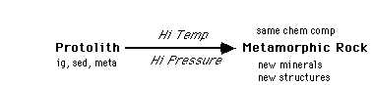
Types of Metamorphism: Metamorphic recrystallization is caused by one or both of 1) elevated temperatures and 2) high pressures
1) Regional Metamorphism is the result of high pressures and elevated temperatures associated with deep burial in an orogenic belt. Platy minerals (micas) and elongate minerals (hornblende) recrystallize and/or rotate into a new orientation perpendicular to the applied stress, while other minerals recrystallize into new crystals which are stable at the higher pressures and temperatures.
Foliation is the result of the parallel arrangement of (micas, etc.) in a plane perpendicular to the maximum principal applied stress. A lineation is caused by a similar growth of elongate minerals (eg. hornblende) in this plane. Slate, schist, and gneiss are three common foliated metamorphic rocks. Slate is a hard, fine-grained rock with a well-developed rock cleavage or slaty cleavage caused by the incipient growth of platy (micaceous) minerals, due to metamorphism of fine-grained clastic sediments such as shale and siltstone and also volcanic tuffs. Schist is a still higher degree of metamorphism, characterized by coarse grained foliation and/or lineation, with mica crystals large enough to be easily identified with the unaided eye. Gneiss is a medium to coarse-grained, irregularly banded rock with only poorly developed cleavage. The light and dark bands (gneissic banding) are alternations of felsic vs. mafic layers.
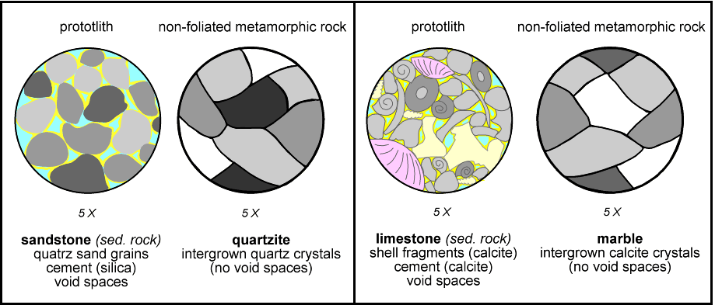
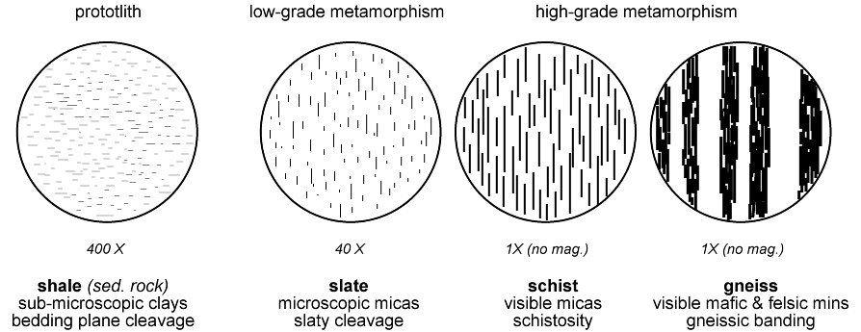
Slate is a product of low grade metamorphism (not terribly great burial temperatures and pressures are required). Schist and gneiss are produced by medium to high grade metamorphism. In some cases gneisses are produced by higher grade metamorphism than schists. Low-grade metamorphic rocks tend to be fine-grained (the newly formed metamorphic mineral grains that is). High-grade metamorphic rocks tend to be coarse-grained. But grain size is also dependent on the grain size of the protolith.
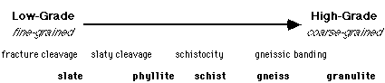
Non-foliated metamorphic rocks include quartzite, which is metamorphosed sandstone in which the quartz grains have recrystallized into a very solid interlocking network, and marble, which is metamorphosed limestone composed of recrystallized and interlocking calcite or dolomite crystals.
Foliation in metamorphic rocks is related to the orientation of the applied stresses and not the original sedimentary or earlier metamorphic structures. The original shale bedding (relict bedding) is sometimes preserved as color contrasts in a slate. In most cases the slate's fracture cleavage lies at some angle to the original bedding plane.
Three other types of metamorphism are important in certain tectonic environments.
2) Contact Metamorphism is the result of baking the surrounding country rocks by an igneous intrusion. The metamorphic aureole surrounding an igneous body may be only 2 centimeters wide adjacent to a small dike or it may be 2 kilometers wide at the contact with a large, slow-cooling granite pluton. Contact metamorphosed rocks may be bleached out looking and non-descript fine-grained. A common contact metamorphic rock is hornfels (German for "hard rock").
3) Hydrothermal alteration, sometimes considered a form of metamorphism, is related to the circulation of hot, mineral-laden fluids through rock bodies. This is particularly important in alteration of ocean crust in the high heat flow regime near the mid-ocean ridges. Serpentinites form from the hydration of peridotites, olivine rich rocks at the base of the oceanic crust. Hydrothermal alteration also occurs as a result of hot fluids escaping from a cooling pluton, in addition to the high-temperature contact metamorphism occurring there.
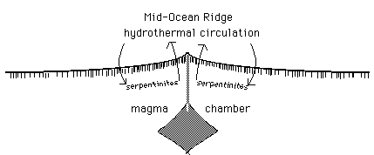
4) Cataclastic metamorphic rocks form where rocks are being faulted and sheared. Cataclasite or fault breccias form in brittle fault zones and consist of larger angular rock fragments dispersed in a fine-grained matrix. Mylonites are foliated, actually sheared, stretched, and streaked rocks, formed in plastic shear zones, at depths and pressures too great for rock to break. The rock becomes drawn out like modeling clay or bubble gum.
Source: www.columbia.edu/~vjd1/meta_rx.htm

